PAC-Poly-Tonga-Five Coastal Is-Cook-1784

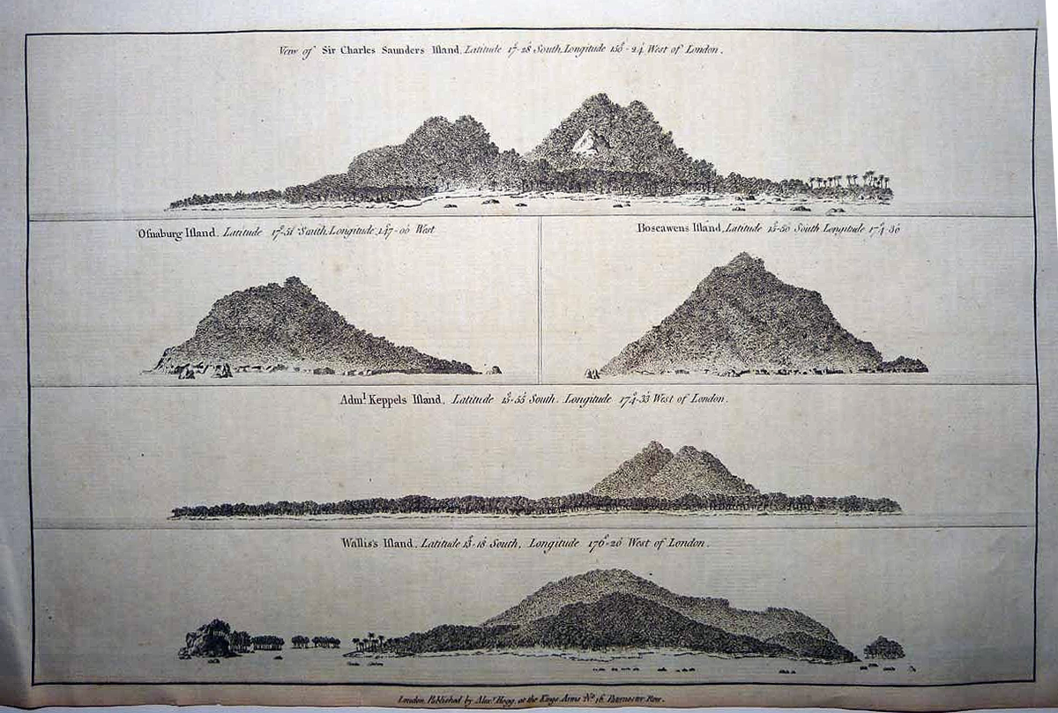

## Sir Charles Saunders Island - Osnaburg Island - Boscawens Island - Admiral Keppel's Island - Wallis Island

33 cm x 21 cm copperplate engraving, 38 cm x 24 cm sheet size, Alexander Hogg, London, 1786

We are pleased to offer this scarce original chart from George William Anderson's account of "Captain Cook's First, Second, Third and Last Voyages" featuring coastal profiles of five islands in or nearby the Tonga Islands group.  Shown are [Maiao](http://en.wikipedia.org/wiki/Maiao) (Sir Charles Saunders Island) the Windward Islands of the Society Islands, [Mehetia](http://en.wikipedia.org/wiki/Mehetia) in the Society Islands (Osnaburg Island), [Niuatoputapu](http://en.wikipedia.org/wiki/Niuatoputapu) (Admiral Keppel Island), [Tafahi](http://en.wikipedia.org/wiki/Tafahi) (Boscawens Island)which adjoins Niuatoputapu and [Wallis Island](http://en.wikipedia.org/wiki/Wallis_(island)) in the Wallis and Futuna Island group.  This well preserved example will make an important addition to any collection related to the voyages of James Cook and the exploration of the South Pacific.  In addition, it will serve as a reminder of an important charitable contribution - ***100%*** of the proceeds from your purchase will be donated to [Médecins Sans Frontières](http://www.doctorswithoutborders.org/home.cfm) (Doctors Without Borders) whose important humanitarian work sadly remains in critical demand around the globe.

